Objectives:

* Random class

**There are 2 challenge exercises with 2 print screens, each worth 50%**

Please submit this document for grading when completed… Please work in groups.

A random class allows the computer to assign random numbers. We use the import statement to use the random class.

**Project #1** (using the random class), notice that we use the import statement to use the random class.

The **randint** means to use random numbers between 1-10, try increasing the numbers, and rerun the program.

Here is an example using the for loop to print the random numbers.

**Project #2** (Heads and Tails)

**Project #3** (the rock, paper, scissor game)

**Project #4** (using the math class)

**Challenge Exercise #1:** complete the following program using a function.

**#1 Print screen the output with the code below here.**

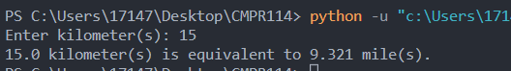

Code:

def convert_to_miles(input):

convert_val = input * 0.6214

return convert_val

def main():

userinput = float(input("Enter kilometer(s): "))

newval = convert_to_miles(userinput)

print(f"{userinput} kilometer(s) is equivalent to {newval} mile(s).")

main()

**Challenge Exercise #2:** complete the following program using a function.

**#2 Print screen the output with the code below here.**

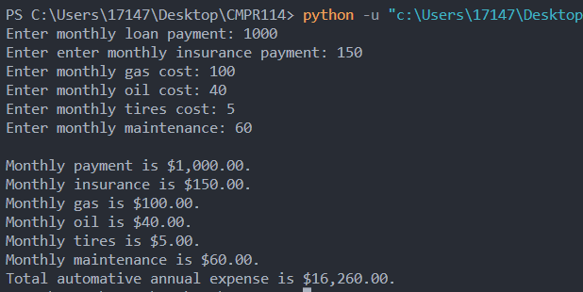

Code:

def yearly_auto_expense(payment, insurance, gas, oil, tires, maintenance):

totalexpense = (payment + insurance + gas + oil + tires + maintenance) * 12

return totalexpense

def main():

payment = float(input("Enter monthly loan payment: "))

insurance = float(input("Enter enter monthly insurance payment: "))

gas = float(input("Enter monthly gas cost: "))

oil = float(input("Enter monthly oil cost: "))

tires = float(input("Enter monthly tires cost: "))

maintenance = float(input("Enter monthly maintenance: "))

annualexpense = yearly_auto_expense(payment, insurance, gas, oil, tires, maintenance)

print(f"\nMonthly payment is ${payment:,.2f}.")

print(f"Monthly insurance is ${insurance:,.2f}.")

print(f"Monthly gas is ${gas:,.2f}.")

print(f"Monthly oil is ${oil:,.2f}.")

print(f"Monthly tires is ${tires:,.2f}.")

print(f"Monthly maintenance is ${maintenance:,.2f}.")

print(f"Total automative annual expense is ${annualexpense:,.2f}.")

main()

**Submit this document to the Module 2 Class Exercise.**